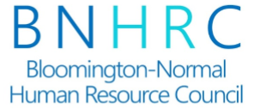
Speaker Request Form
Thank you for your interest in speaking at an upcoming BNHRC meeting. Please complete the information below to be considered for a future speaking engagement. The completed form and any supporting information should be sent to programming@bnhrc.org.

Thank you for wanting to share your knowledge with our local HR community.

Name:
Title:
Presentation Title:
Presentation Fee:

Presentation Length: 60 minutes (generally, including questions and answer time)

Presenter Contact Information:
Phone:
Email:
Website:
Links where prior presentations can be viewed:

Speaker Bio and Photo:
(Please feel free to include your bio and photo as an attachment.)

General overview of the program/presentation:
(this will also be used to promote the program to our members)

Specific learning objectives:
What will attendees learn as a result of attending?
What are the take-aways?
Why is this presentation important for HR professionals to attend?

If you have a copy of your presentation, we would appreciate a copy to turn in with our certification request. If not, this is not a problem.

If this presentation has been previously certified by the HRCI or SHRM, please include the session number: ___________________.
(Please disregard if not applicable)

